Chord
# Source: AI Source: Provided by: [Data Path: Persons Table -> ID Column: 1, Name_En Column: Motasem Essam] -> From: [ChatGPT] on [7/25/2026]
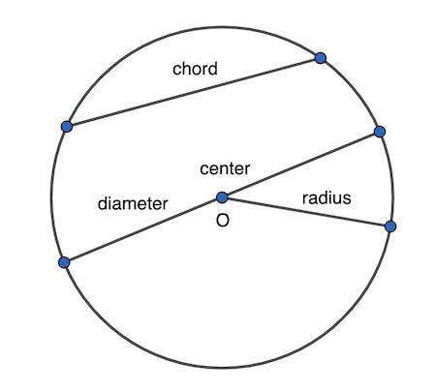
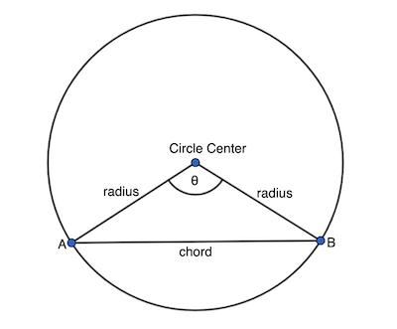
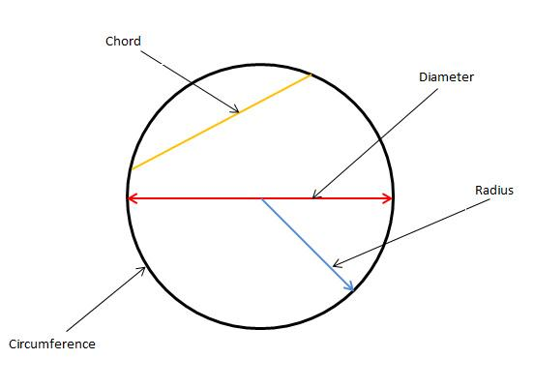
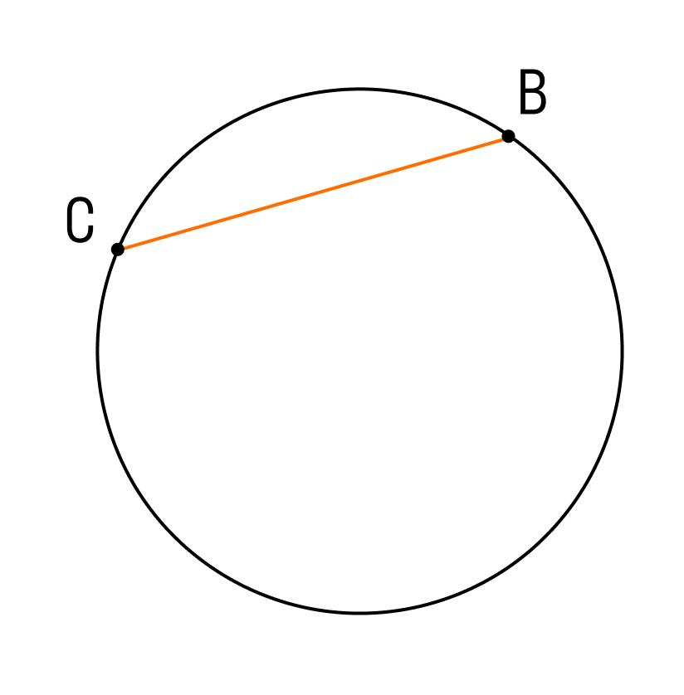
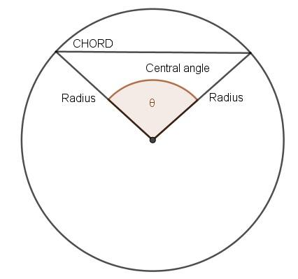

Definition
# Source: AI Source: Provided by: [Data Path: Persons Table -> ID Column: 1, Name_En Column: Motasem Essam] -> From: [ChatGPT] on [7/25/2026]
A chord is a line segment whose two endpoints lie on the circumference of a circle.
If $A$and $B$are points on a circle, then:
$$\overset{‾}{AB}$$
is a chord.
The chord does not have to pass through the center.

Fundamental Elements
# Source: AI Source: Provided by: [Data Path: Persons Table -> ID Column: 1, Name_En Column: Motasem Essam] -> From: [ChatGPT] on [7/25/2026]
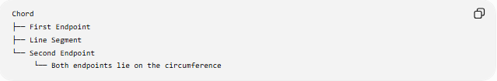
Chord
├── First Endpoint
├── Line Segment
└── Second Endpoint
└── Both endpoints lie on the circumference
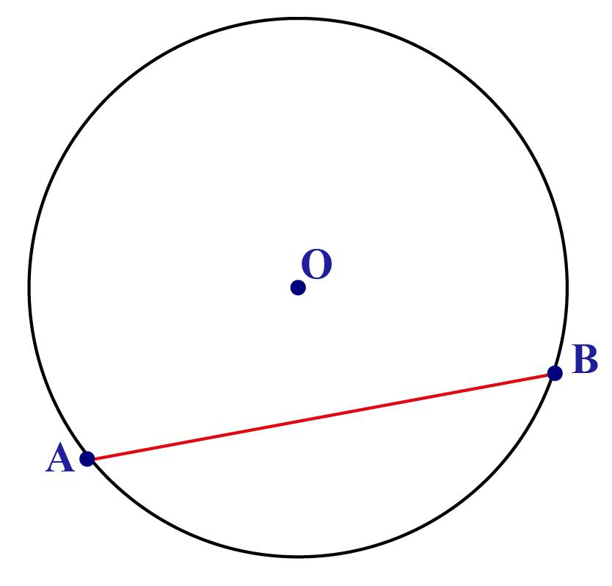
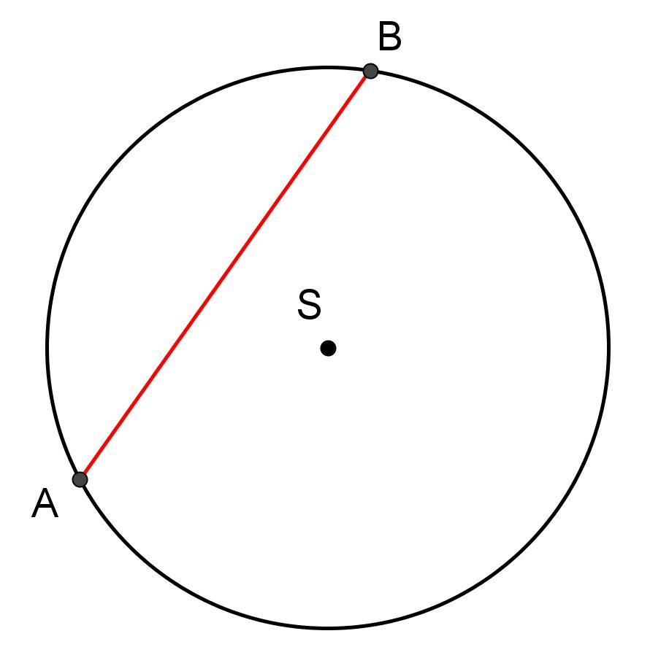

Main Properties
# Source: AI Source: Provided by: [Data Path: Persons Table -> ID Column: 1, Name_En Column: Motasem Essam] -> From: [ChatGPT] on [7/25/2026]
- A chord is a line segment, not an infinite line.
- Both endpoints of a chord lie on the circumference.
- A chord can pass through the center.
- A chord that passes through the center is called a diameter.
- A circle has infinitely many chords.
- The diameter is the longest possible chord of a circle.

Chord vs Diameter vs Radius
# Source: AI Source: Provided by: [Data Path: Persons Table -> ID Column: 1, Name_En Column: Motasem Essam] -> From: [ChatGPT] on [7/25/2026]
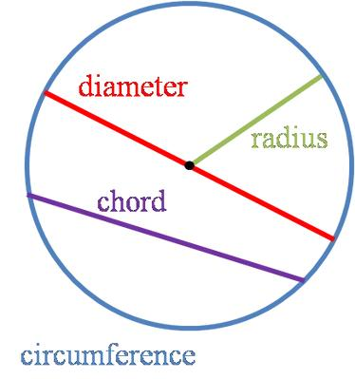
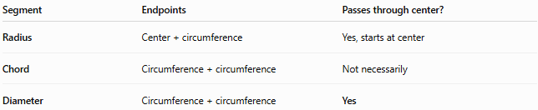
Segment | Endpoints | Passes through center?
Radius | Center + circumference | Yes, starts at center
Chord | Circumference + circumference | Not necessarily
Diameter | Circumference + circumference | Yes
Therefore:
$$\boxed{\text{Every diameter is a chord}}$$
but:
$$\boxed{\text{Not every chord is a diameter}}$$

Types of Chords

1. Diameter Chord
# Source: AI Source: Provided by: [Data Path: Persons Table -> ID Column: 1, Name_En Column: Motasem Essam] -> From: [ChatGPT] on [7/25/2026]
A chord passing through the center.
$$\boxed{d=2r}$$

2. Minor Chord
# Source: AI Source: Provided by: [Data Path: Persons Table -> ID Column: 1, Name_En Column: Motasem Essam] -> From: [ChatGPT] on [7/25/2026]
A chord that cuts off a minor arc.

3. Major Chord
# Source: AI Source: Provided by: [Data Path: Persons Table -> ID Column: 1, Name_En Column: Motasem Essam] -> From: [ChatGPT] on [7/25/2026]
In elementary geometry, chords themselves are not usually classified as "major" or "minor"; rather, the arc determined by a chord is called a minor or major arc. The chord is simply the segment joining the arc's endpoints.

Chord Length
# Source: AI Source: Provided by: [Data Path: Persons Table -> ID Column: 1, Name_En Column: Motasem Essam] -> From: [ChatGPT] on [7/25/2026]
For a circle of radius $r$, if a chord is at perpendicular distance $h$from the center:
$$\boxed{L=2\sqrt{r^{2}-h^{2}}}$$
where:
- $L$= chord length
- $r$= circle radius
- $h$= perpendicular distance from center to chord
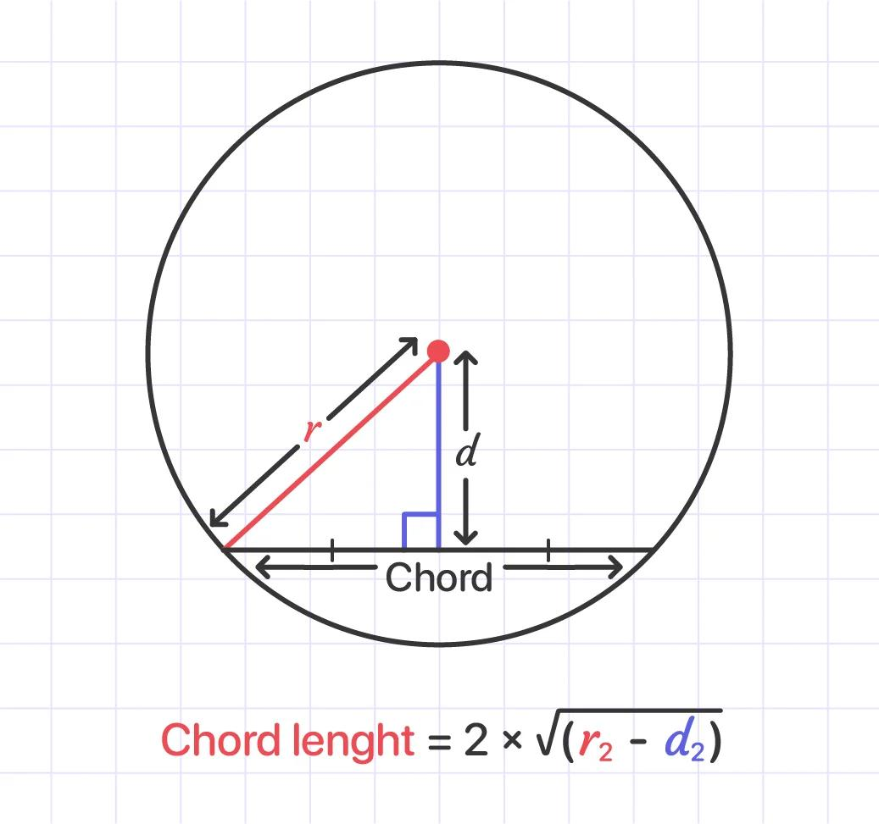
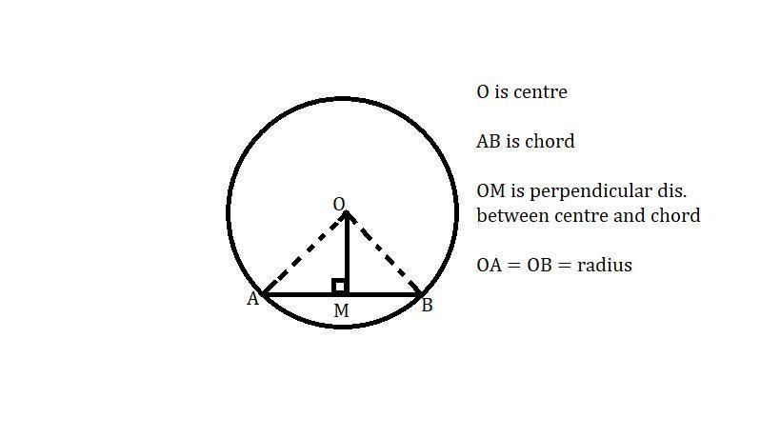
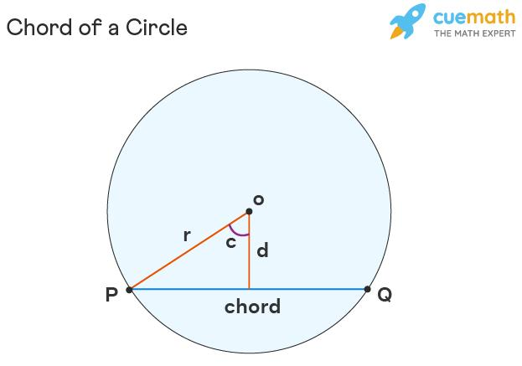
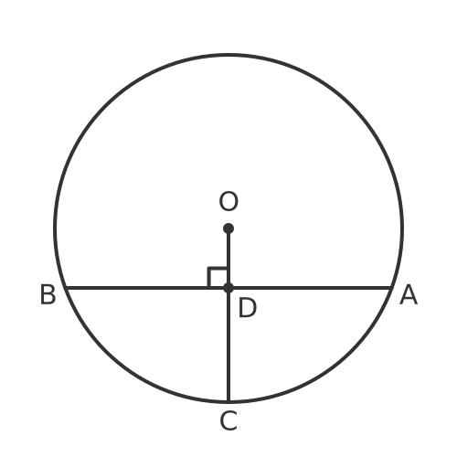
Example
If:
$$r=5\text{ cm}$$
and the chord is:
$$h=3\text{ cm}$$
from the center:
$$L=2\sqrt{5^{2}-3^{2}} \\ L=2\sqrt{25-9} \\ L=2\sqrt{16} \\ \boxed{L=8\text{ cm}}$$

Important Chord Theorems

Perpendicular from Center to a Chord
# Source: AI Source: Provided by: [Data Path: Persons Table -> ID Column: 1, Name_En Column: Motasem Essam] -> From: [ChatGPT] on [7/25/2026]
A perpendicular drawn from the center of a circle to a chord bisects the chord.
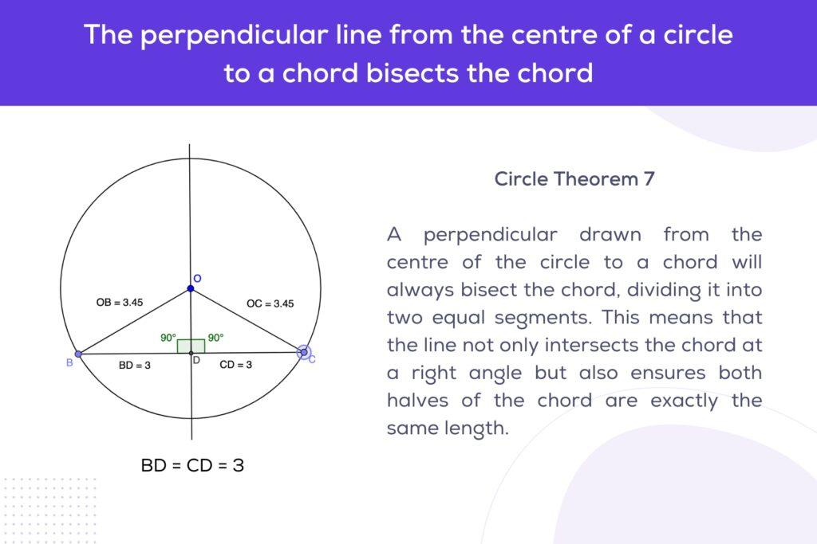
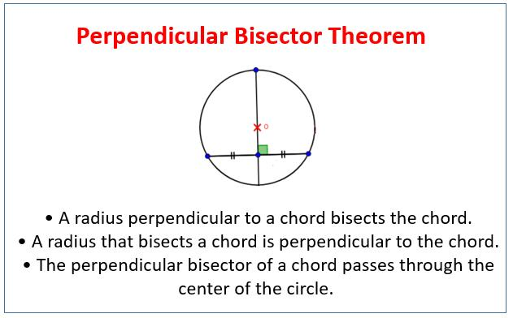
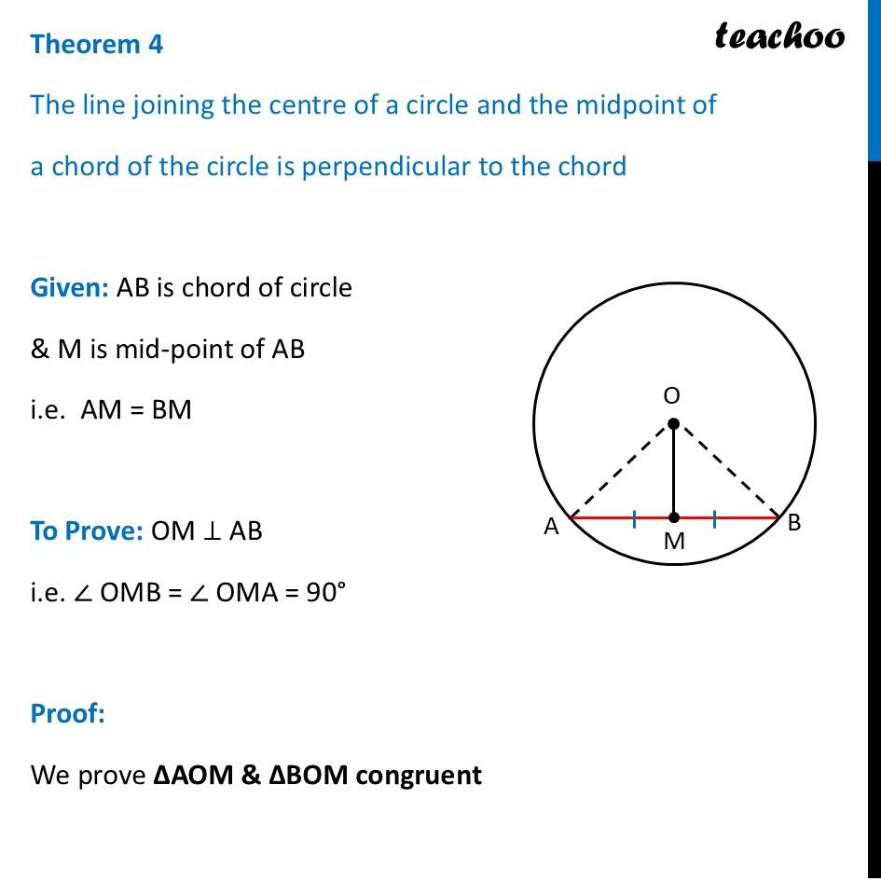
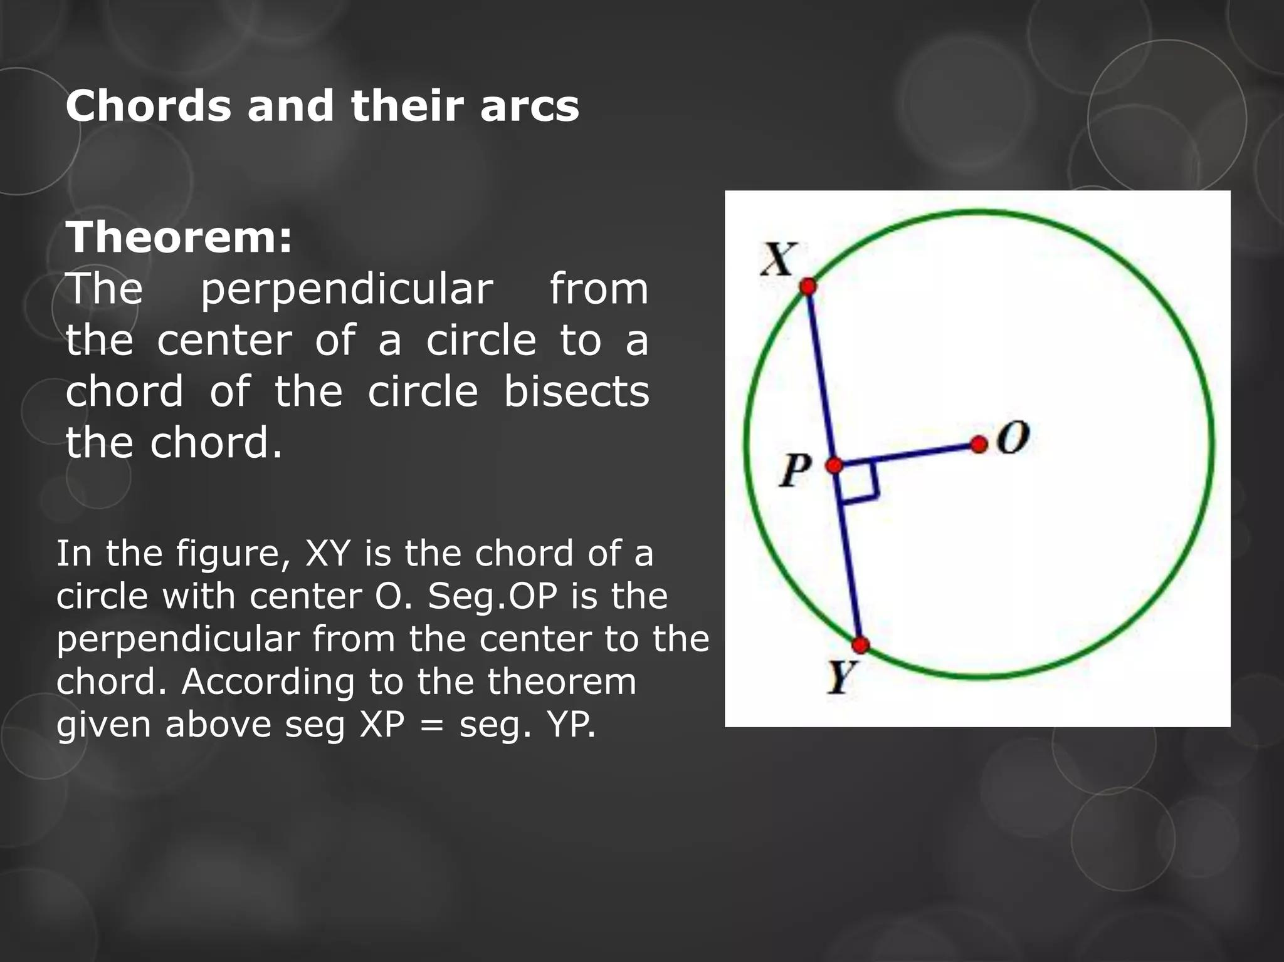
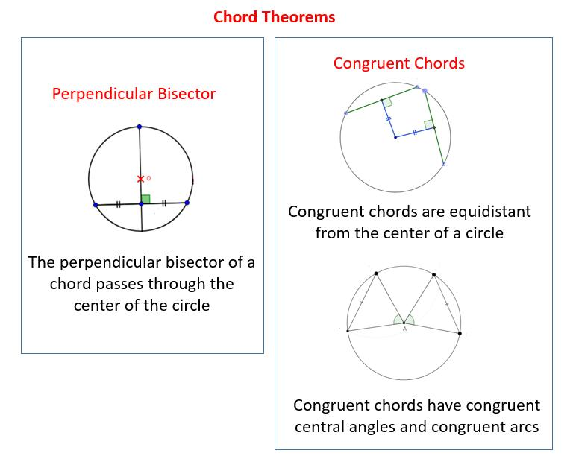
If $OM⊥AB$, then:
$$\boxed{AM=MB}$$

Equal Chords
# Source: AI Source: Provided by: [Data Path: Persons Table -> ID Column: 1, Name_En Column: Motasem Essam] -> From: [ChatGPT] on [7/25/2026]
Equal chords in the same circle are equally distant from the center.
Conversely, chords equally distant from the center are equal.
$$AB=CD ⟺\text{ distance}\left(O , AB\right)=\text{distance}\left(O , CD\right)$$

Equal Chords and Equal Arcs
# Source: AI Source: Provided by: [Data Path: Persons Table -> ID Column: 1, Name_En Column: Motasem Essam] -> From: [ChatGPT] on [7/25/2026]
Equal chords subtend equal arcs.
$$AB=CD⇒\hat{AB}=\hat{CD}$$
and conversely, in the same circle.

Chord and Arc
# Source: AI Source: Provided by: [Data Path: Persons Table -> ID Column: 1, Name_En Column: Motasem Essam] -> From: [ChatGPT] on [7/25/2026]
A chord connects the endpoints of an arc.
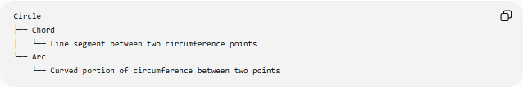
Circle
├── Chord
│ └── Line segment between two circumference points
└── Arc
└── Curved portion of circumference between two points
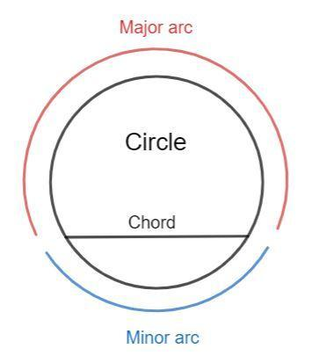
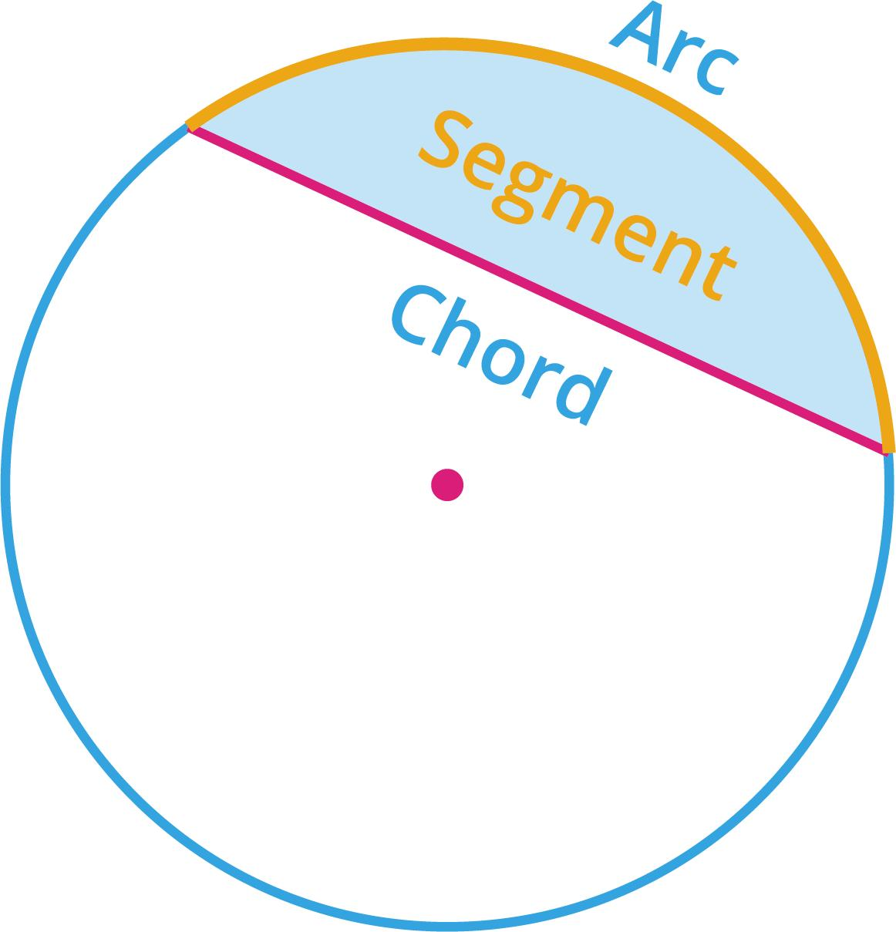
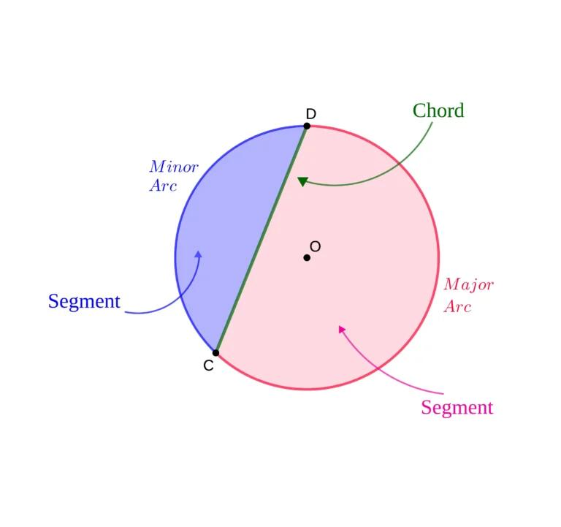
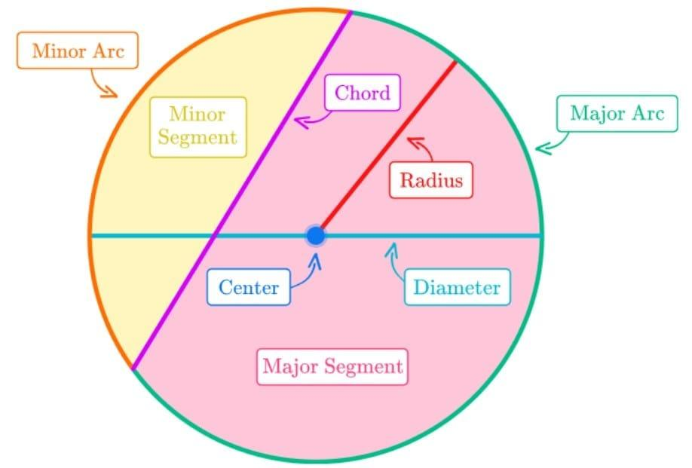

Related Concepts
# Source: AI Source: Provided by: [Data Path: Persons Table -> ID Column: 1, Name_En Column: Motasem Essam] -> From: [ChatGPT] on [7/25/2026]
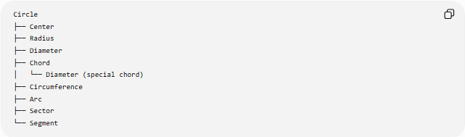
Circle
├── Center
├── Radius
├── Diameter
├── Chord
│ └── Diameter (special chord)
├── Circumference
├── Arc
├── Sector
└── Segment

Key Points
# Source: AI Source: Provided by: [Data Path: Persons Table -> ID Column: 1, Name_En Column: Motasem Essam] -> From: [ChatGPT] on [7/25/2026]
- A chord is a segment with both endpoints on the circumference.
- It does not necessarily pass through the center.
- A diameter is a special chord that passes through the center.
- The diameter is the longest chord.
- A perpendicular from the center to a chord bisects the chord.
$$\boxed{\text{Diameter}⊂\text{Chord}}$$

Conclusion
# Source: AI Source: Provided by: [Data Path: Persons Table -> ID Column: 1, Name_En Column: Motasem Essam] -> From: [ChatGPT] on [7/25/2026]
A chord is one of the fundamental parts of a circle. It connects two points on the circumference and provides important relationships involving diameters, arcs, angles, distances from the center, and circle geometry.

